**Windows installation guide**

1. DB browser for SQLite – Download [page](https://sqlitebrowser.org/dl/)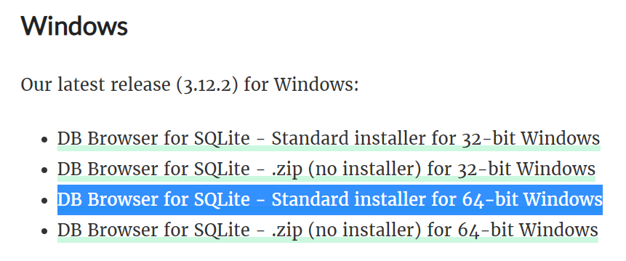
   1. Download the Standard installer for 64-bit Windows
   2. The installation is similar to installing any new software on your computer. There is not a lot of options to select. You will be asked to agree to the “End User License Agreement” and be asked if you want to include a shortcut to the Desktop and/or Program Menu. It’s up to you if you want to include a shortcut; I only selected the Program Menu option.
   3. 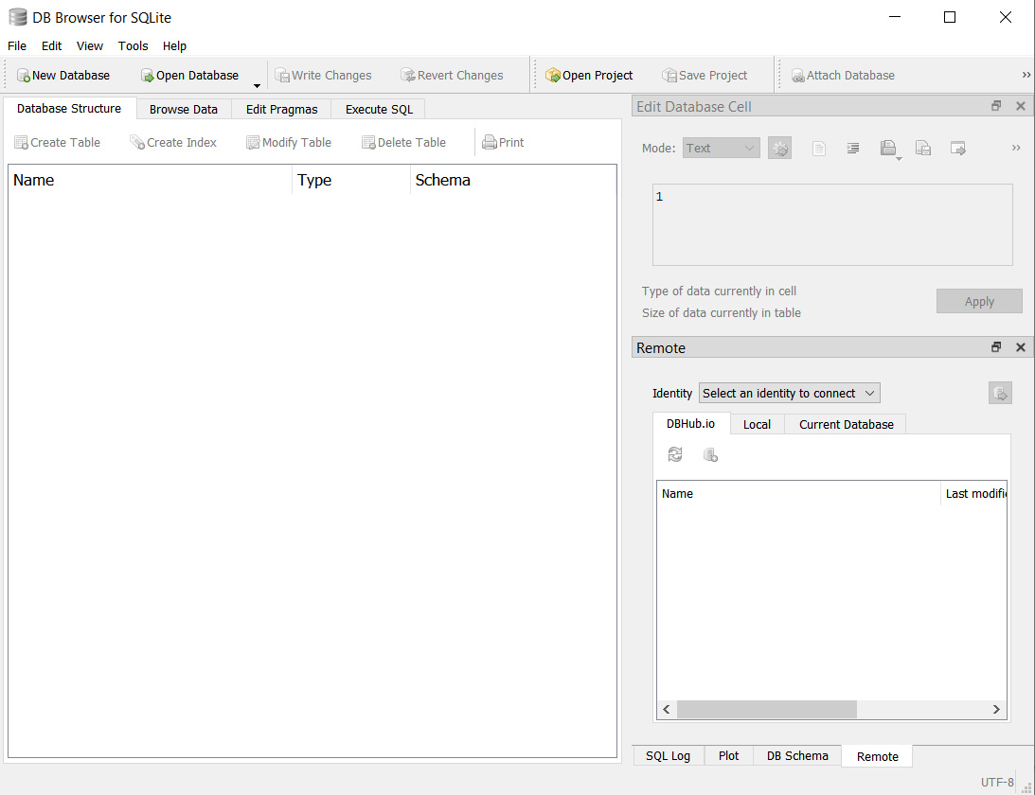After you successfully installed DB Browser, the application will look something like the screenshot below

**Mac installation guide**

1. DB Browser for SQLite
   1. You can install using the download link in the Downloads [page](https://sqlitebrowser.org/dl/), or install using Homebrew (if you use this software). Then just drag the DB Browser icon into your Applications folder.
   2. 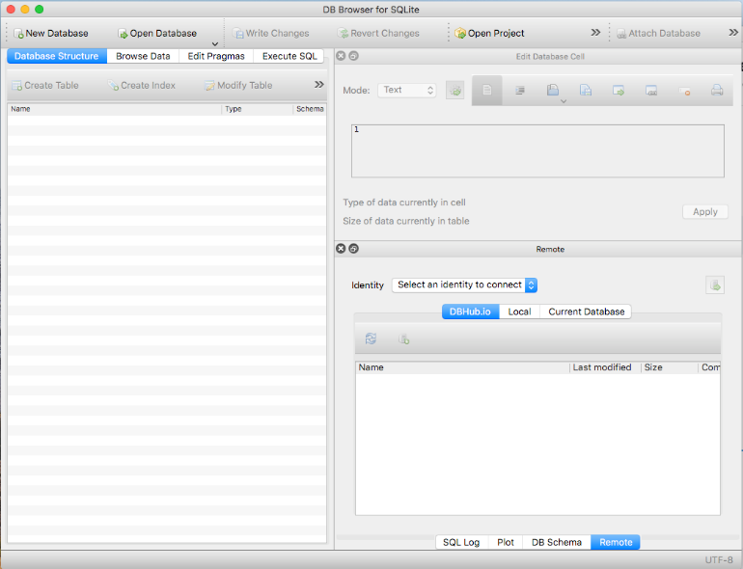After you successfully installed DB Browser, the application will look something like the screenshot below 